****

FLOW CHART for SLATE



STATISTICS

According to the ministry of statistics and programme implementation ( MOSPI) govt of india 2011 census in india there are 372.4 millions of children of age group 0 to 14 among which 273.6 million (73.46%) are from rural and 98.8 millions (26.53%) from urban

According to the report of the National Sample Survey Office (NSSO) 30% of the above stated figures are approximately underprivileged 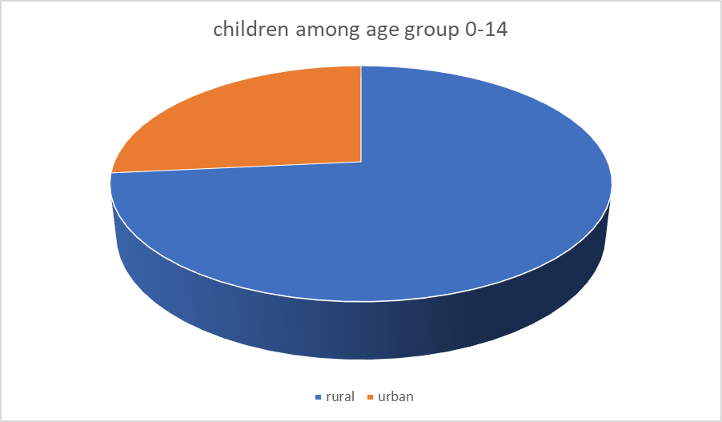

There are 1522346 number of schools in india among which 1102783 (72.4%) are government, 83787 (5.5%) are government aided and rest are private schools

